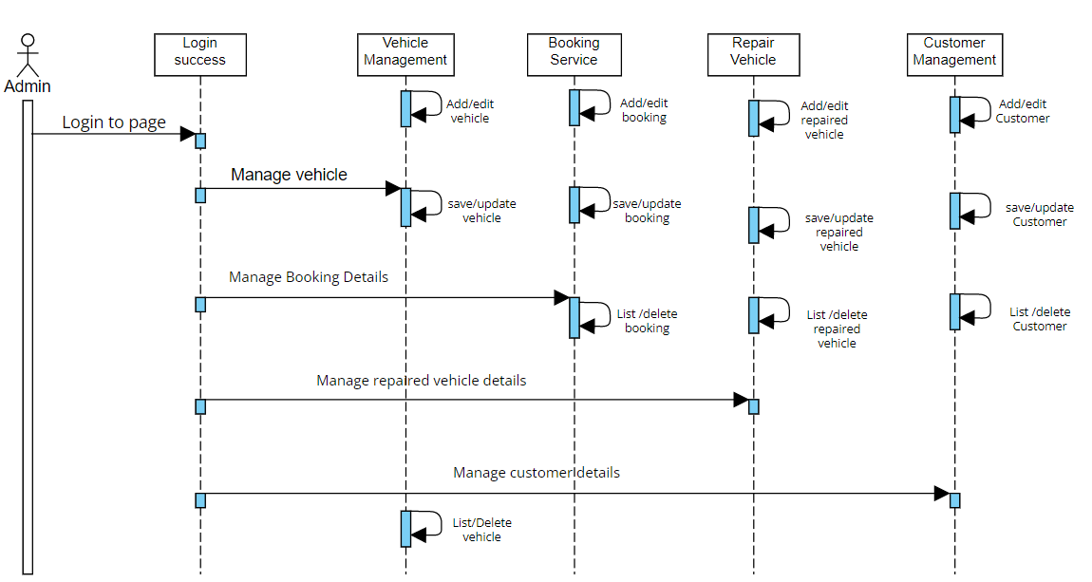**4.Sequence Diagram**

**4.Sequence Diagram**

